**Day 31:**

Creating micro service application using reactive approach with gate way. Call 2 micro service using WebClient.

1. Eureka Server --🡪 8761

Starter 🡪web starter

Starter 🡪 Eureka server

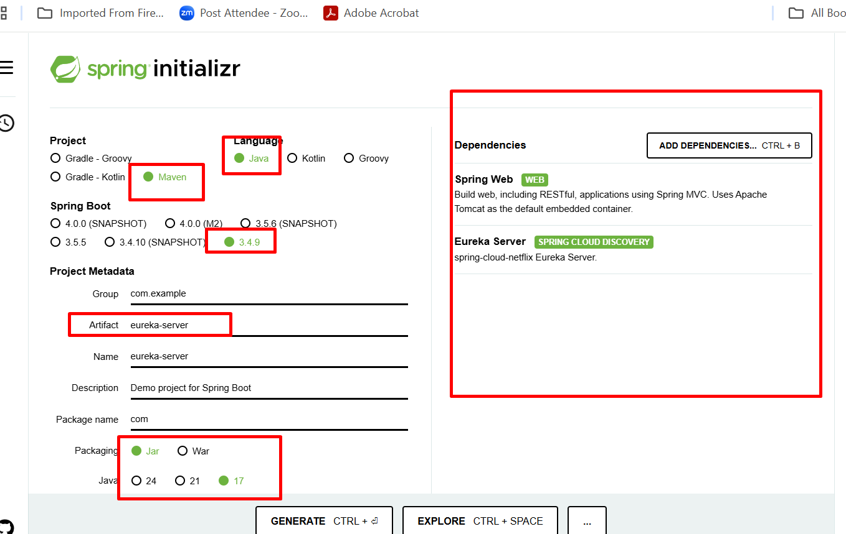

1. Product micro service 🡪 8181

Starter 🡪 flux web starter

Starter 🡪eureka client

Starter 🡪 r2dbs

Dependency 🡪 mysql (we add manually)

Starter 🡪 Lombok

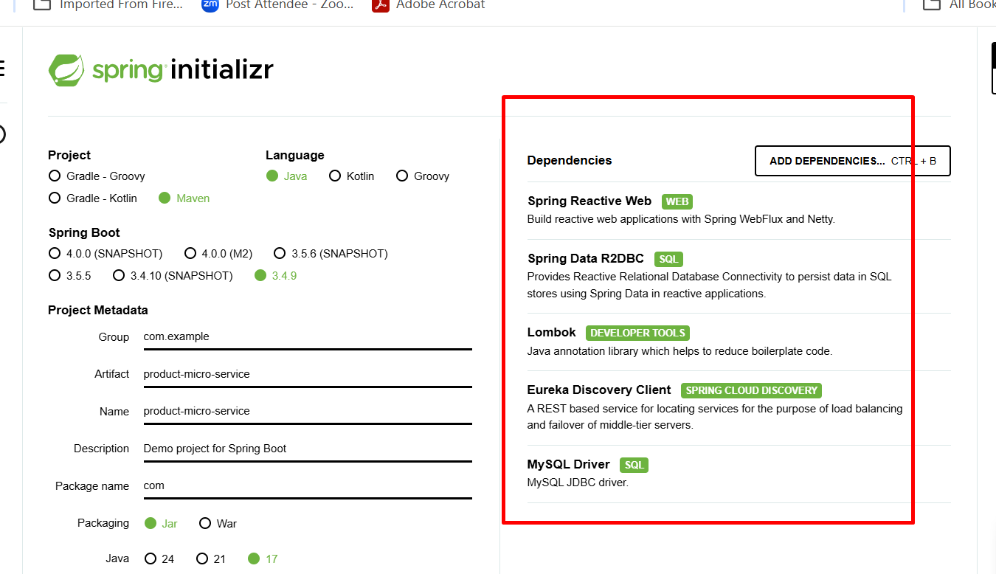

1. Order micro service 🡪 8282

Starter 🡪 flux web starter

Starter 🡪eureka client

Starter 🡪 r2dbs

Dependency 🡪 h2 database

Starter 🡪 Lombok

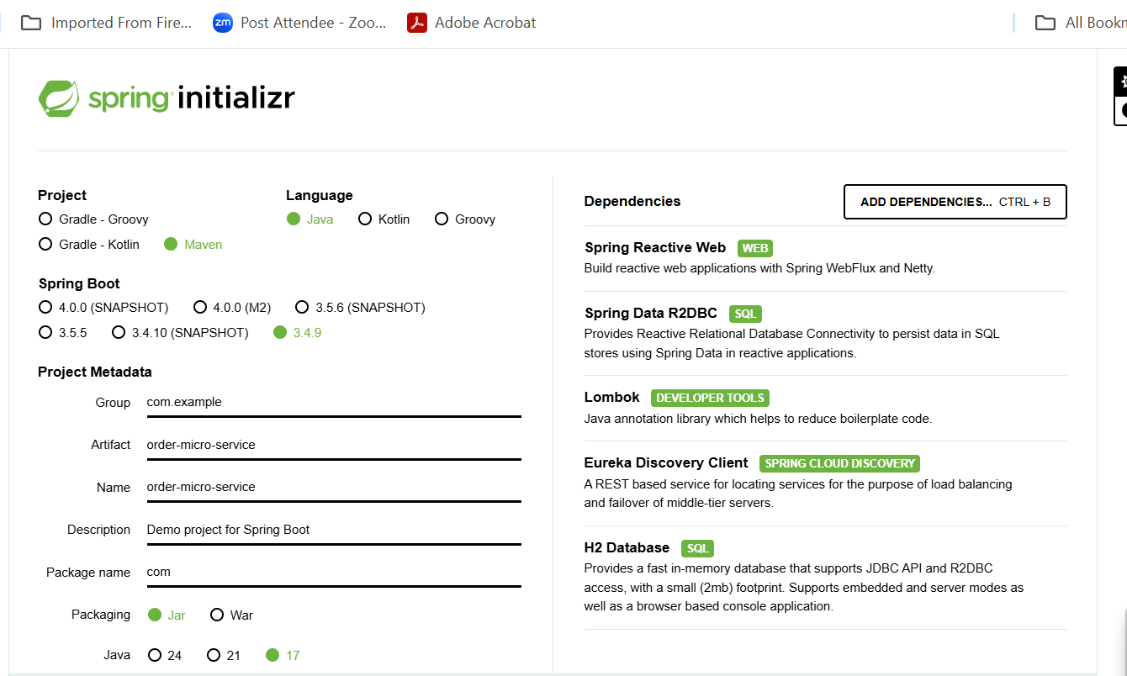

1. Gateway 🡪8080 : main entry point for micro service to keep track.

Starter 🡪web starter

Starter 🡪gateway starter

